## Housing Price Data

Seven San Francisco bay area counties were selected for this study: Alameda, Contra Costa, Marin, San Francisco, San Mateo, Santa Clara and Solano. Selection of counties was based on their relative proximity to the Alameda County. The median-monthly housing price data for each county was obtained from the Zillow research website which spanned from April 1996 to July 2018. The available data was seasonally adjusted housing prices of the single-family homes, condominiums and co-operative houses combined.

## Time Series Plots

Figure 1 shows the time series plot of the selected counties. Few characteristics of the plotted time series were as follows:

1. Housing prices of all counties had similar trends. The housing prices increased linearly from 1996 to about 2006. During this time, housing prices in the Marin County were highest and the housing prices in San Francisco and San Mateo County were almost the same.
2. Due to the real estate recession, the housing prices fell from 2006 and did not properly recover until mid-2011.
3. 2012 onwards, the monthly rate of housing price increase was higher in the San Francisco and San Mateo County but remained almost same as before the period of real estate crisis, for the Solano and Contra Costa County.

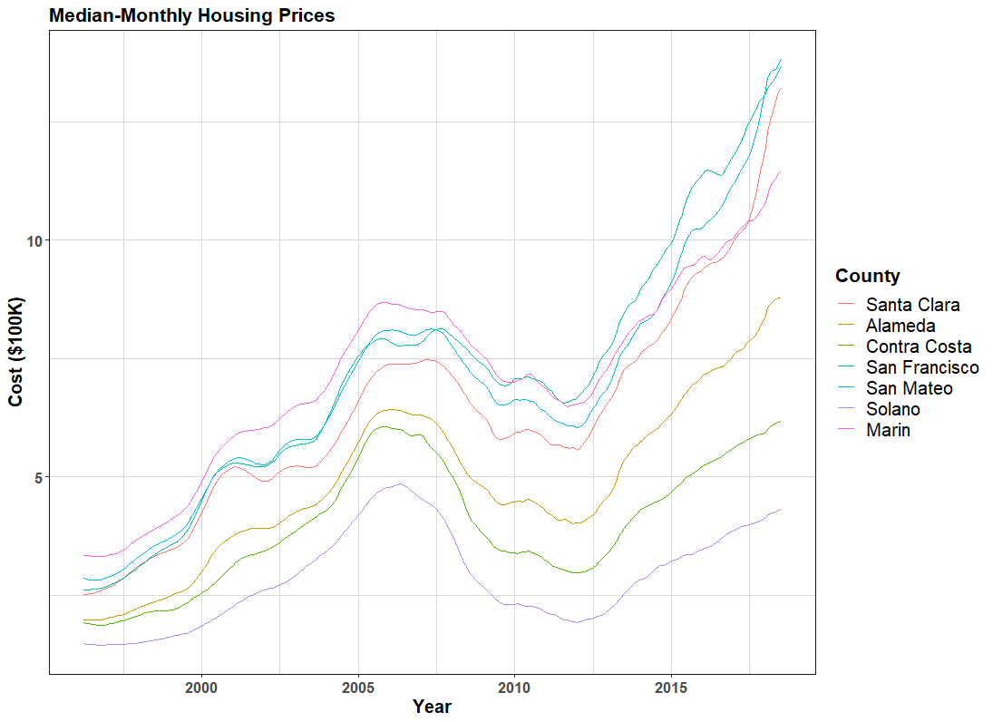

Figure 1 Time series plot of median-monthly hosing prices (in $100,000).

### Correlation Plots

Figure 2 shows the correlation plots and Table 1 lists the correlation matrix entries for the seven counties. As it was evident from the close trend of time series plots, the housing price of Alameda County were highly correlated to the other six counties, highest correlation with Marin County (0.99) and lowest with Solano (0.86).

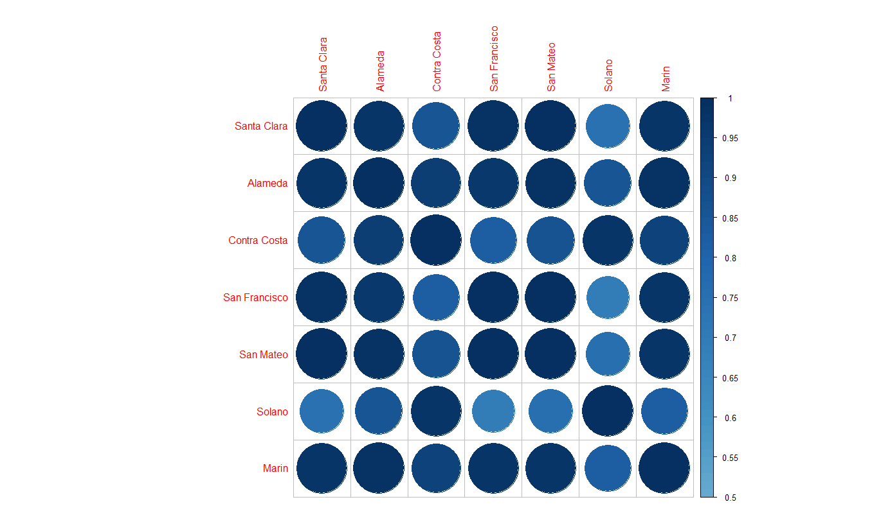

Figure 2 Correlation plot of the seven counties.

Table 1 Coefficient matrix of the seven counties (R output).

Santa Clara Alameda Contra Costa San Francisco San Mateo Solano Marin

Santa Clara 1.0000000 0.9776199 0.8587038 0.9888947 0.9978823 0.7417814 0.9709462

Alameda 0.9776199 1.0000000 0.9428272 0.9659201 0.9823701 0.8556051 0.9893881

Contra Costa 0.8587038 0.9428272 1.0000000 0.8286117 0.8690276 0.9776691 0.9210560

San Francisco 0.9888947 0.9659201 0.8286117 1.0000000 0.9915703 0.6969285 0.9708248

San Mateo 0.9978823 0.9823701 0.8690276 0.9915703 1.0000000 0.7542549 0.9756265

Solano 0.7417814 0.8556051 0.9776691 0.6969285 0.7542549 1.0000000 0.8241027

Marin 0.9709462 0.9893881 0.9210560 0.9708248 0.9756265 0.8241027 1.0000000